# Stakeholder Analysis

Who Are Stakeholders?

A stakeholder is any entity with a declared or conceivable interest or stake in a policy concern. The range of stakeholders relevant to consider for analysis varies according to the complexity of the reform area targeted and the type of reform proposed and, where the stakeholders are not organized, the incentive to include them. Stakeholders can be of any form, size and capacity. They can be individuals, organizations, or unorganized groups. In most cases, stakeholders fall into one or more of the following categories: international actors (e.g. donors), national or political actors (e.g. legislators, governors), public sector agencies (e.g. MDAs), interest groups (e.g. unions, medical associations), commercial/private for-profit, nonprofit organizations (NGOs, foundations), civil society members, and users/consumers

# What is Stakeholder Analysis

. Stakeholder Analysis (SA) is a methodology used to facilitate institutional and policy reform processes by accounting for and often incorporating the needs of those who have a ‘stake’ or an interest in the project under consideration. With information on stakeholders, their interests, and their capacity to oppose the project, the project Planners can choose how to best accommodate them, thus assuring project outcomes are politically realistic and sustainable.

The benefits of using a stakeholder-based approach are that:

* You can use the opinions of the most powerful stakeholders to shape your projects at an early stage. Not only does this make it more likely that they will support you, their input can also improve the quality of your project
* Gaining support from powerful stakeholders can help you to win more resources – this makes it more likely that your projects will be successful
* By communicating with stakeholders early and frequently, you can ensure that they fully understand what you are doing and understand the benefits of your project – this means they can support you actively when necessary
* You can anticipate what people's reaction to your project may be, and build into your plan the actions that will win people's support.

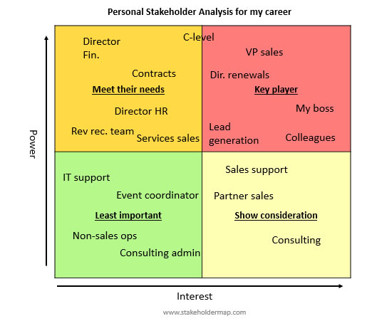

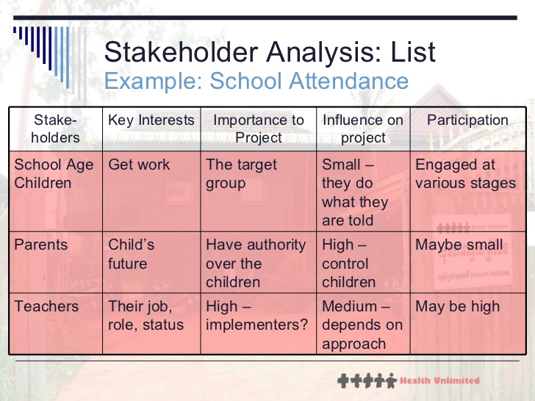

# Problem Analysis

Problem tree analysis helps stakeholders to establish a realistic overview and awareness of the problem by identifying the fundamental causes and their most important effects. The main output of the exercise is a tree-shaped diagram in which the trunk represents the focal problem, the roots represent its causes and the branches its effects. Such a problem tree diagram creates a logical hierarchy of causes and effects and visualizes the links between them. It creates a summary picture of the existing negative situation.

### : Problem Analysis

The problem analysis is the phase in which the negative aspects of a [given situation](http://www.sswm.info/category/planning-process-tools/decision-making#Situation and Problem Analysis) are identified, establishing the cause and effect relationship between the observed problems. The [problem analysis](http://www.sswm.info/category/planning-process-tools/decision-making#Situation and Problem Analysis) is of prime importance with regard to [project planning](http://www.sswm.info/category/planning-process-tools/decision-making#Planning with the Community), since it strongly influences the design of all possible interventions. The problem analysis includes

* Definition of the framework and the subject of analysis.
* Identification of problems faced by target groups and beneficiaries.
* Visualisation of the problems in form of a diagram, called “problem tree” to help analyse and clarify cause-effect relationships.

Like any other tree, the problem tree has three parts: a trunk, roots, and branches. The trunk is the main problem. The roots represent the causes of the core problem while the branches represent its effects. The following figure shows an example of a problem tree related to [river](http://www.sswm.info/glossary/2/letterr#term2679) pollution.

[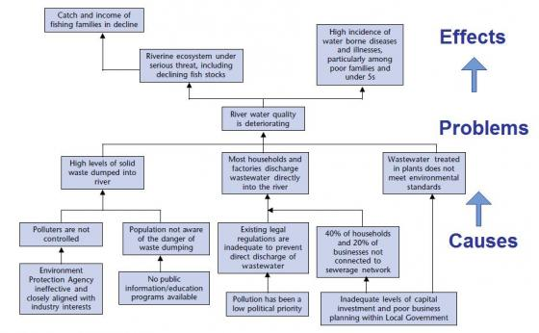](http://www.sswm.info/sites/default/files/toolbox/EC%202004%201%20Example%20of%20a%20Problem%20Tree.jpg)